1.First, update the repositories:

**sudo apt update**

.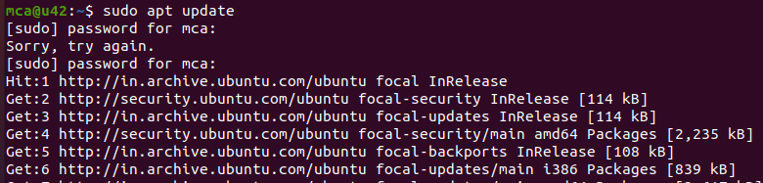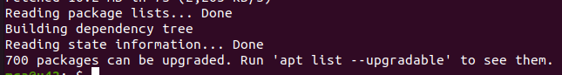

2. Before you begin with installing KVM, check if your CPU supports hardware virtualization vi

**egrep -c 'vmx|svm' /proc/cpuinfo**

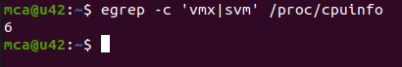

.

3. Then, install essential KVM packages with the following command:

**sudo apt install qemu-kvm libvirt-daemon-system libvirt-clients bridge-utils**

When prompted, type Y, press **ENTER**, and wait for the installation to finish.

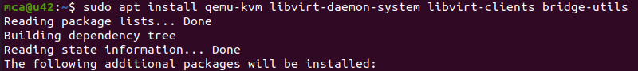

4.

**sudo modprobe vhost net**



5. **sudo lsmod |grep vhost**



6. to verify

7.sudo apt install virt-manager

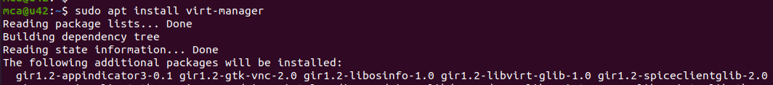

8.**sudo systemctl enable --now libvirtd**



**sudo virt-manager**

